Nama : Tsaniya Faridah Maulida
NIM : 211331031
Kelas : 1A – TTE
Elektronika Analog

LATIHAN SOAL BAB 5

- a. What is the expected amplification of a BJT transistor amplifier if the dc supply is set to zero volts?
b. What will happen to the output ac signal if the dc level is insufficient? Sketch the effect on the waveform.
c. What is the conversion efficiency of an amplifier in which the effective value of the current through a 2.2-k load is 5 mA and the drain on the 18-V dc supply is 3.8 mA?

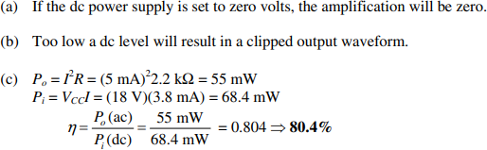
- Can you think of an analogy that would explain the importance of the dc level on the resulting ac gain?

- If a transistor amplifier has more than one dc source, can the superposition theorem be applied to obtain the response of each dc source and algebraically add the results?
- What is the reactance of a 10µF capacitor at a frequency of 1 kHz? For networks in which the resistor levels are typically in the kilohm range, is it a good assumption to use the short-circuit equivalence for the conditions just described? How about at 100 kHz?

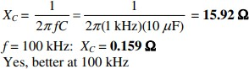

- Given the common-base configuration of Fig. 5.150 , sketch the ac equivalent using the notation for the transistor model appearing in Fig. 5.7 .

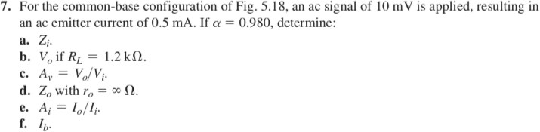
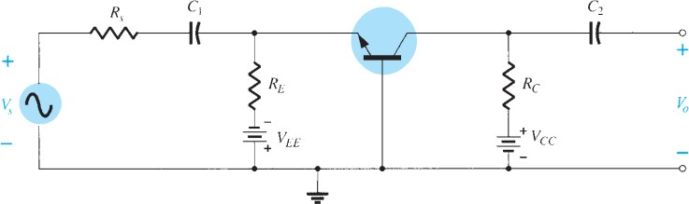
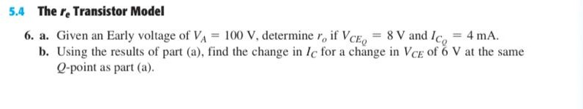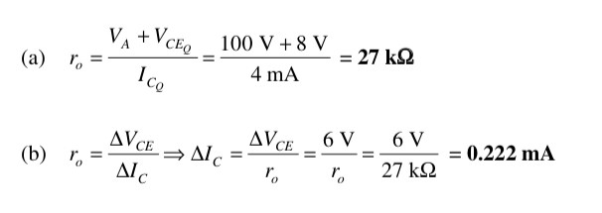

  - For the common-base configuration of Fig. 5. l8, the dc emitter current is 3.2 mA and a is 0.99. Determine the following if the applied voltage is 48 mV and the load is 2.2 kn.
    - rz.
    - Z,. if

e. A .

d. A„ ifyft,_ =481.2 kf1.

(a) r —— ' ”" -- i‹n
I; 3.2 mA

(b) Z, —— r, —— 15 f2

(c) I z —— cd, —— (0.99)(3.2 mA) = 3.168 mA

(d) Vy - !c i - (3.168 mA)(2.2 kn) - 6•97 V

(e) A — V _ 6.97 V 145.21
V, 48 mV

(f) Iz —— (1 — @( —— (1 — 0.99)i. = (0.01)(3.2 mA)
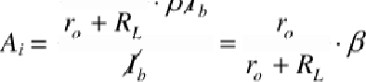=S2
40 kf2
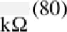
40 k0 + 1.2
= 77.67

d A - °’ r, _ 1.2 kE2)40 k0
” " " r, " " t3 El
1.165 kf2
13 f2

9. The input impedance to a common-emitter transistor amplifier is 1. 2 kf1 with Q 14t l,
rp —— so kn, md «, - 2.7 kf1. Determine:

b. If if V; —— 3O m V.
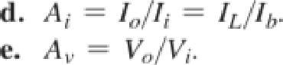

(a) 2i —- Qr‹ —- (l40)r, = 1200
gg _ 1200 _ 8.57 f2
(b) I _ V, 30 mV = 25,«A
Z; 1.2 kf2

(c) I,. -- fill -- (140)(25 ,uA) = 3.5 mA

A, ——

(e) A, ——
r I _ (50 kf2)(3.5 mA) =3.321 mA
r + Rz 50 kf2 + 2.7 kf2
3.321 mA = 132.84
” = = —(132.84) (2.7 kf2)

V, Z 1.2 k£2
= —298.59

  - For the network of Fig. 5.151 :
    - Determine Zi and Zo .
    - Find Av .
    - Repeat parts (a) and (b) with ro = 20 kΩ. Jawab :

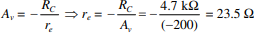
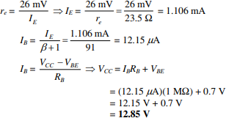

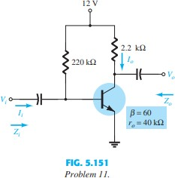
  - 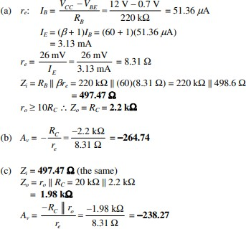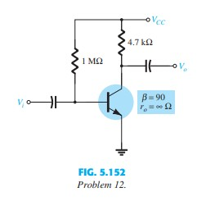For the network of Fig. 5.152 ,
determine VCC for a voltage gain of Av =
-160.

Jawab :

  - For the network of Fig. 5.153 :

    - Calculate IB, IC , and re .
    - Determine Zi and Zo .
    - Calculate Av .
    - Determine the effect of ro = 30 kΩ on Av .

  - For r the network of Fig. 5.153 , what value of RC will cut the voltage gain to half the value obtaine

Jawab :

  - For the network of Fig. 5.154
    - Determine 𝑟_{𝑒} .
    - Calculate 𝑍_{𝑖} and 𝑍_{𝑜} .
    - Find 𝐴_{𝑣} .
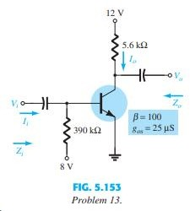
    - Repeat parts (b) and (c) with ro = 25 kΩ.

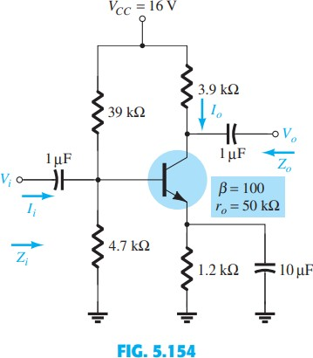
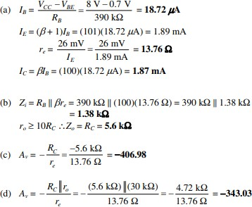
Jawab:
a.

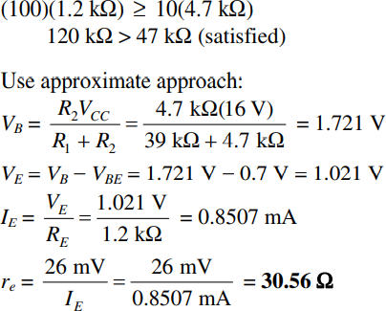

b.
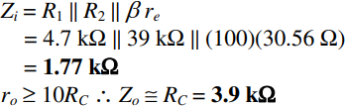

c.
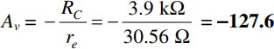

d.

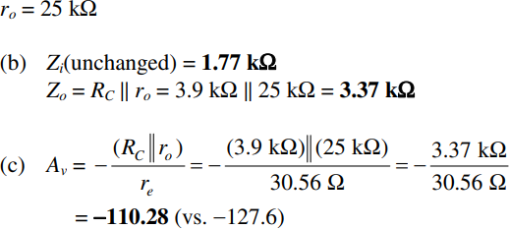

  - Determine 𝑉_{𝑐𝑐} for the network of Fig. 5.155 if 𝐴_{𝑣}= -160 and 𝑟_{𝑜}= 100 kΩ.
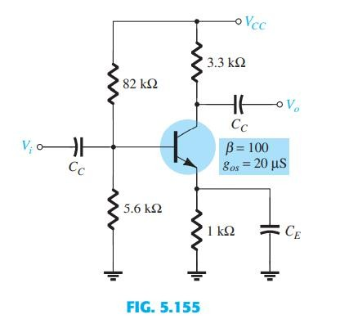

Jawab:

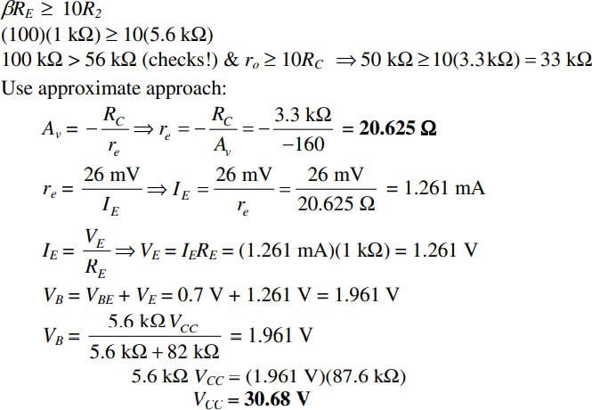

  - For the network of Fig. 5.156 :
    - Determine𝑟_{𝑒}.
    - Calculate 𝑉_{𝑏}and 𝑉_{𝑐}.
    - Determine 𝑍_{𝑖}and 𝐴_{𝑣}= Vo>Vi.

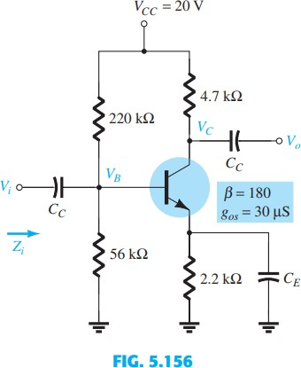

Jawab:

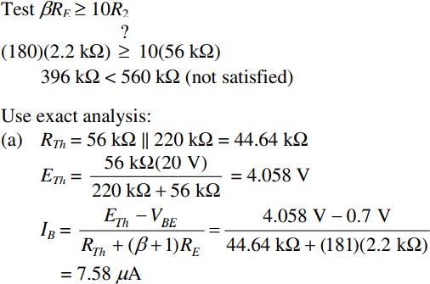
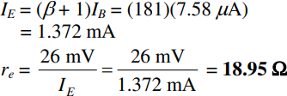
a.

b.
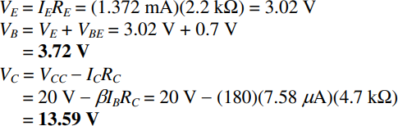

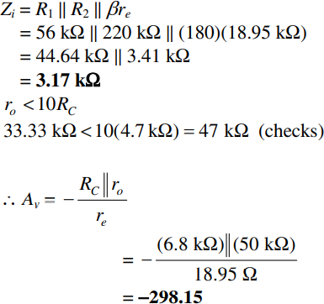
C,

  - For the network of Fig. 5.157 :
    - Determine𝑟_{𝑒}.
    - Find the dc voltages 𝑉_{𝐵}, 𝑉_{𝐶𝐵}, and 𝑉_{𝐶}.
    - Determine 𝑍_{𝑖}and 𝑍_{𝑜}.
    - Calculate 𝐴_{𝑣} V o>V i .

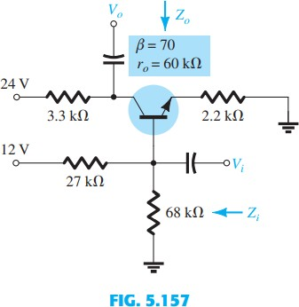

Jawab:

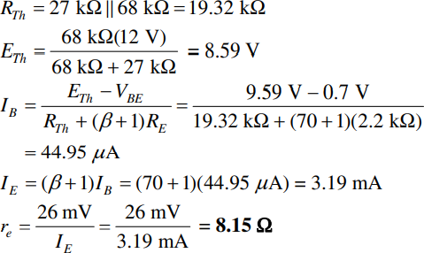
a.
b.
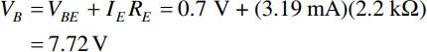

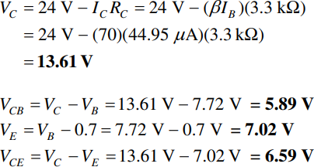

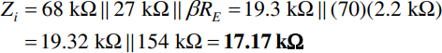
c.

d.
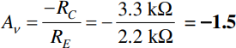

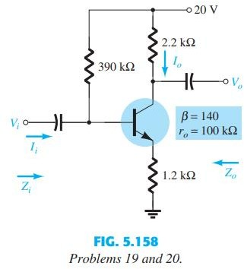
  - For the network of Fig. 5.158 :
    - Determine r e .
    - Find Z i and Z o .
    - Calculate A v .
    - Repeat parts (b) and (c) with ro = 20 k ohm.
➢

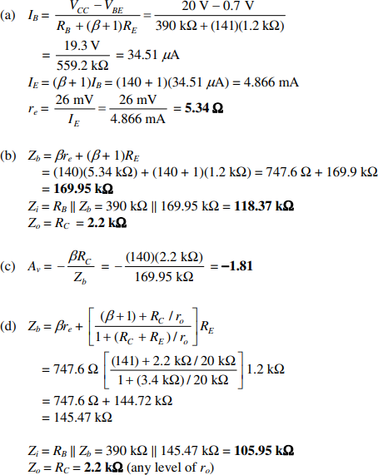

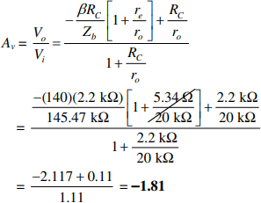

  - Repeat Problem 19 with R E bypassed. Compare results.
➢
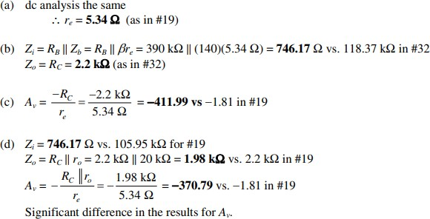

  - For the network of Fig. 5.159 , determine R E and R B if Av = -10 and re = 3.8 ohm. Assume that Zb = bRE.

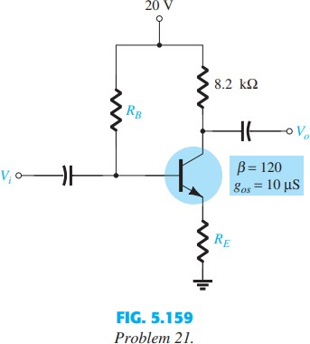

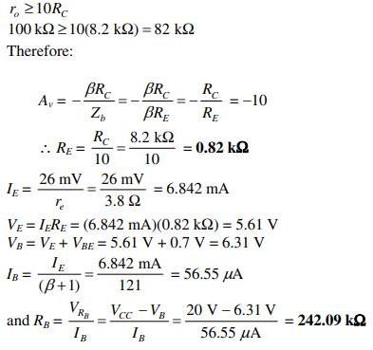
➢

  - For the network of Fig. 5.160 :
    - Determine r e .
    - Find Z i and A v .

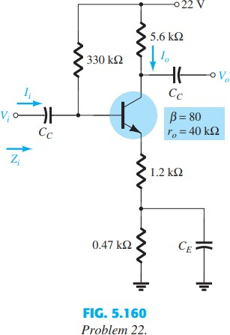
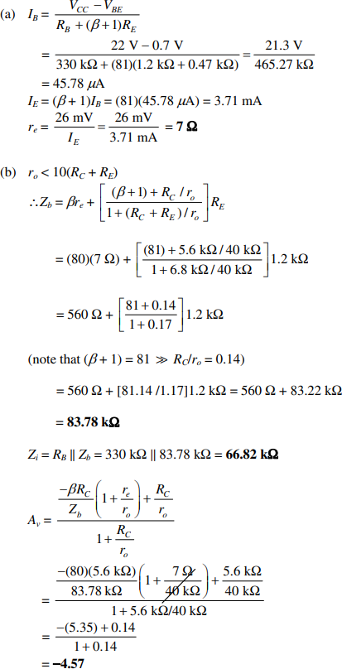
➢

7, = " =“
r
” = —203.49
2

@ = (—203.49j{l3.76 LI) = 26 kO

